**ERICOMP PCR Machine ‘quick-start guide’**

This guide is not meant to be a replacement but meant to accompany the company guide book. It can be used as a quick guide for how to use Ericomp PCR machines.

The manufacturer’s guide can be found here: <https://goo.gl/60XL1P>.

All of The ODIN’s equipment manuals may be found here: <https://goo.gl/7hUKai>

**ERICOMP thermal cycler**

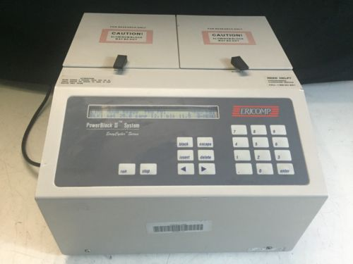

To enter a new program, or run an existing program, follow these steps:

Turn on the machine using the button on the left. The following screen should appear:

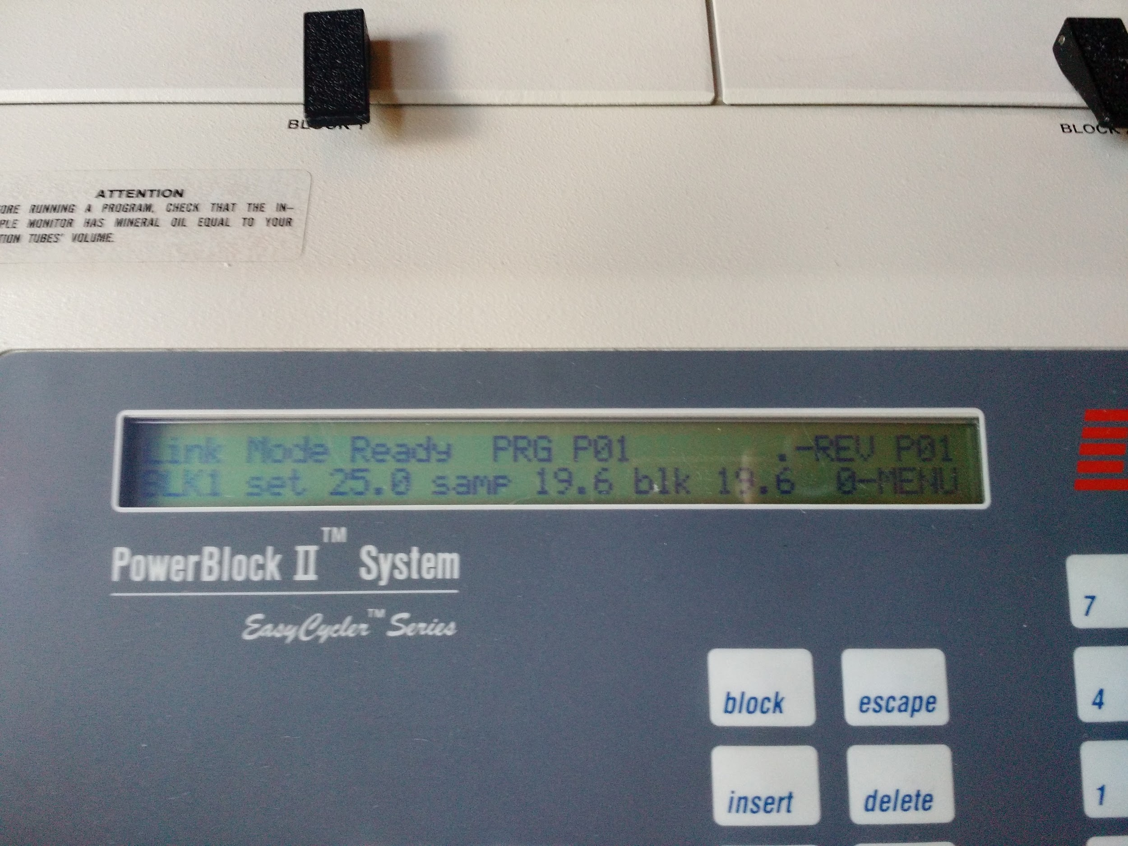

PRESS “0” to go to the next screen...

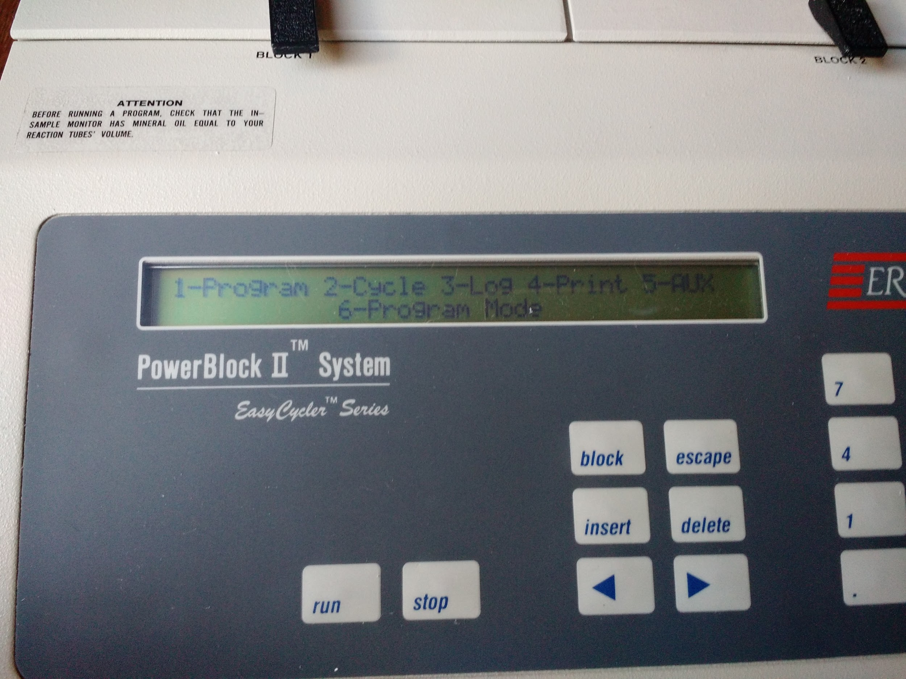

PRESS “6” to go to program mode...

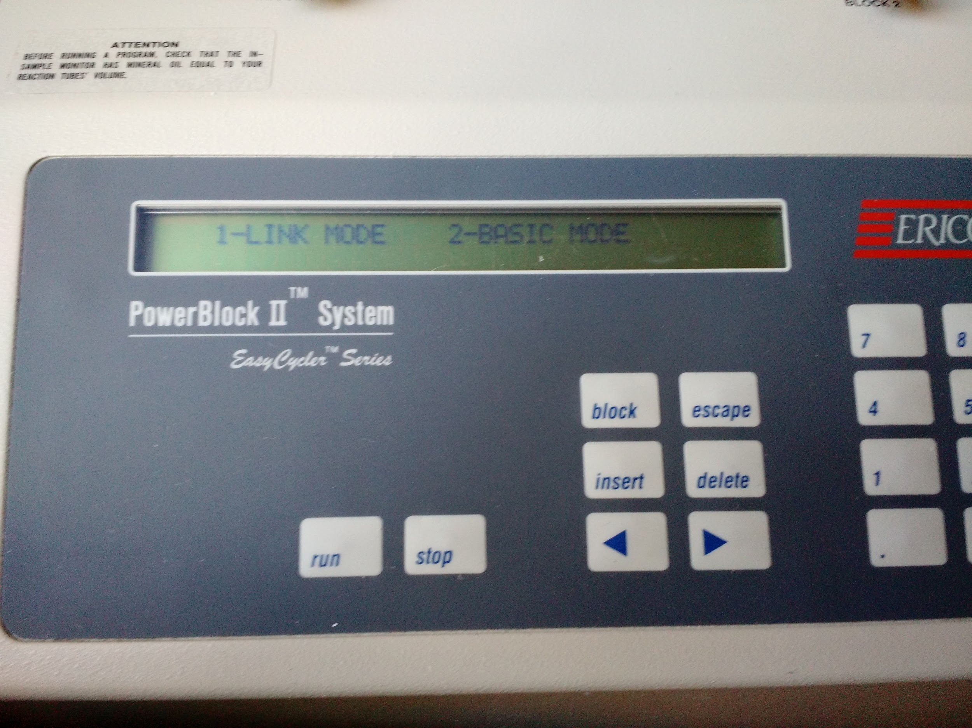

PRESS “2” to go to basic mode...

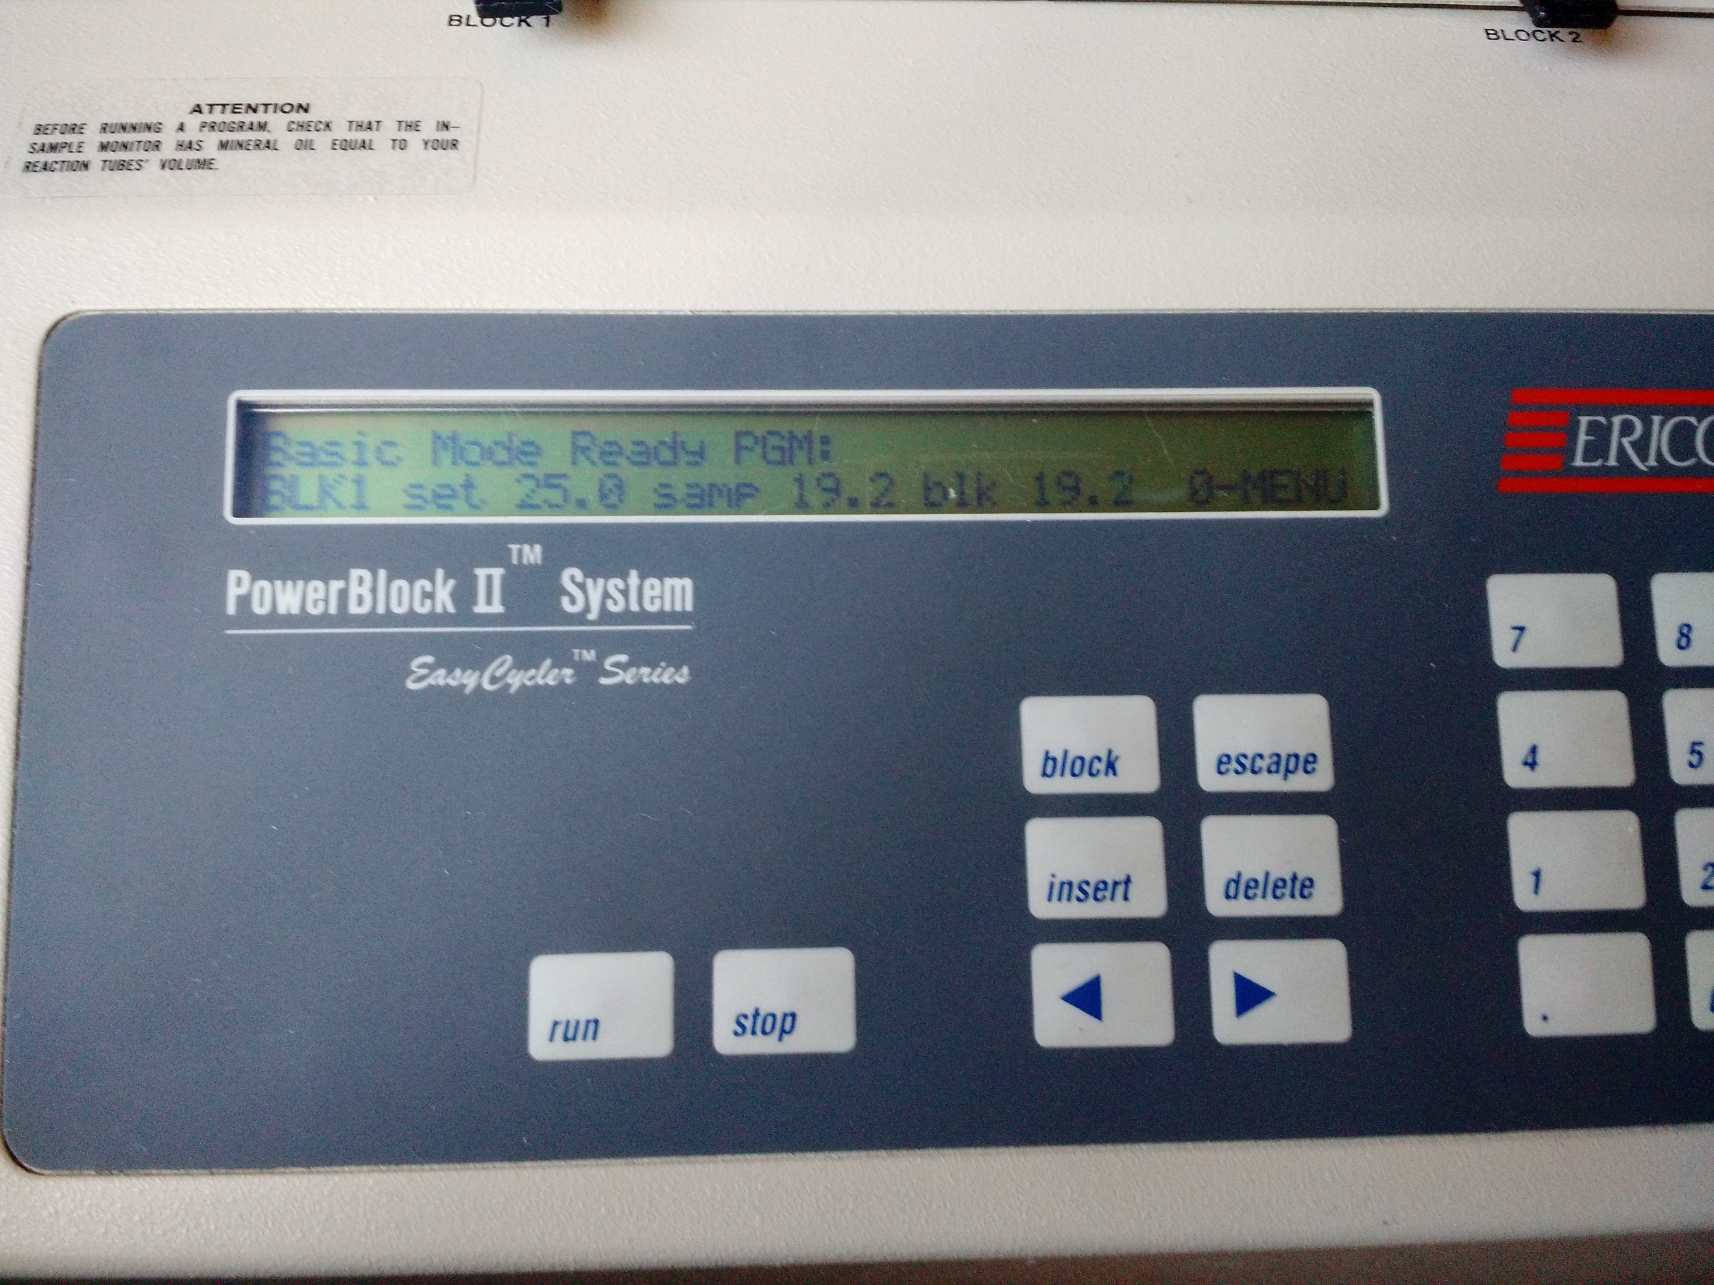

PRESS “0” to select MENU

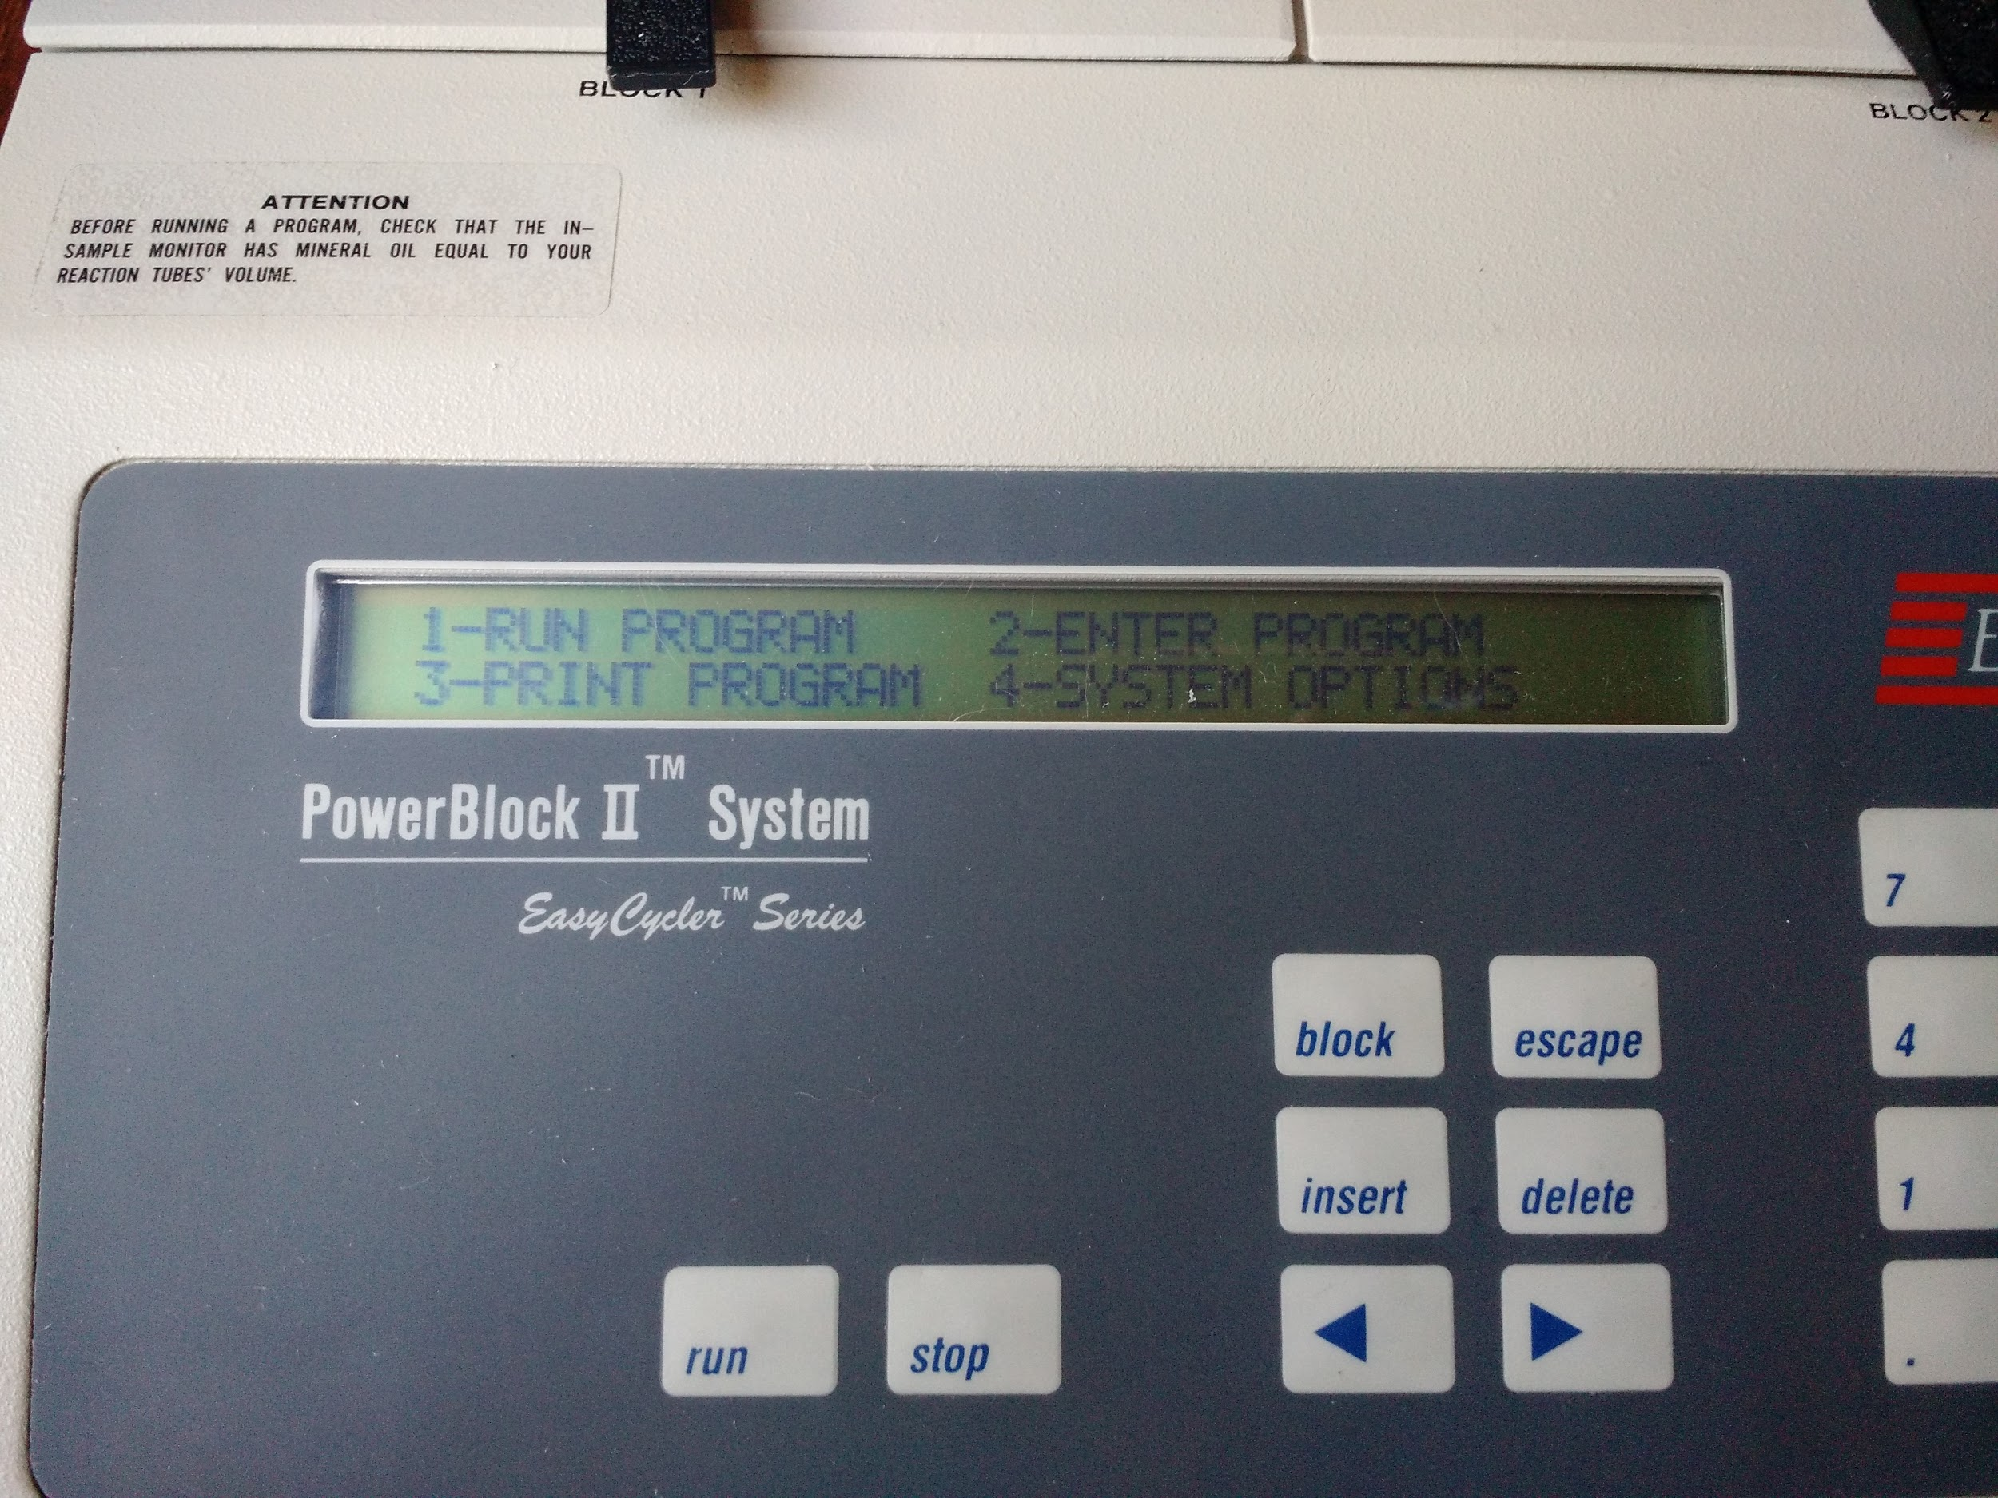

PRESS “2” to enter a new program

**OR**

PRESS “1” to run an existing program (if you’ve already entered one)

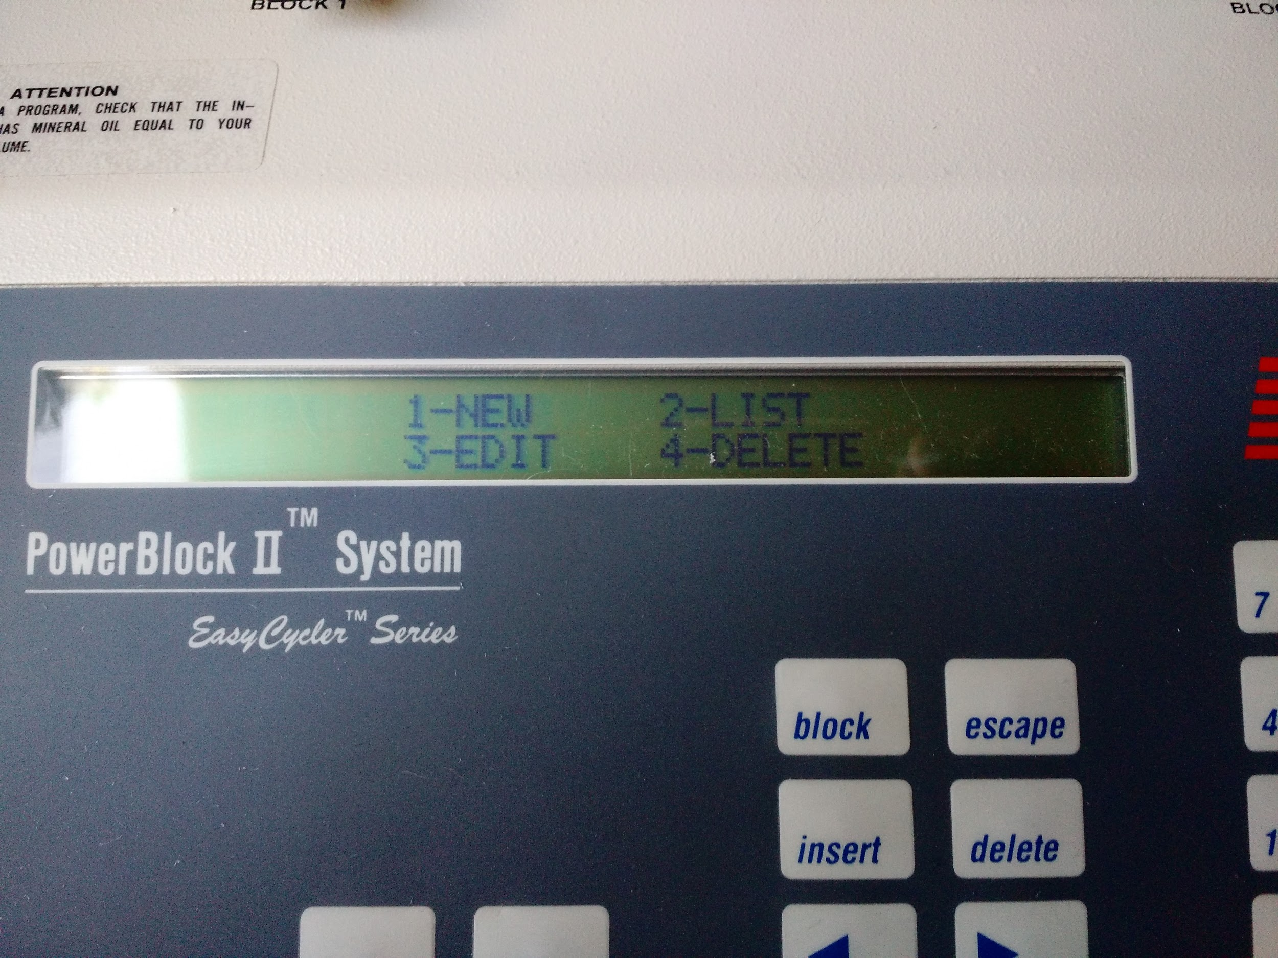

Hit “1” for a new program

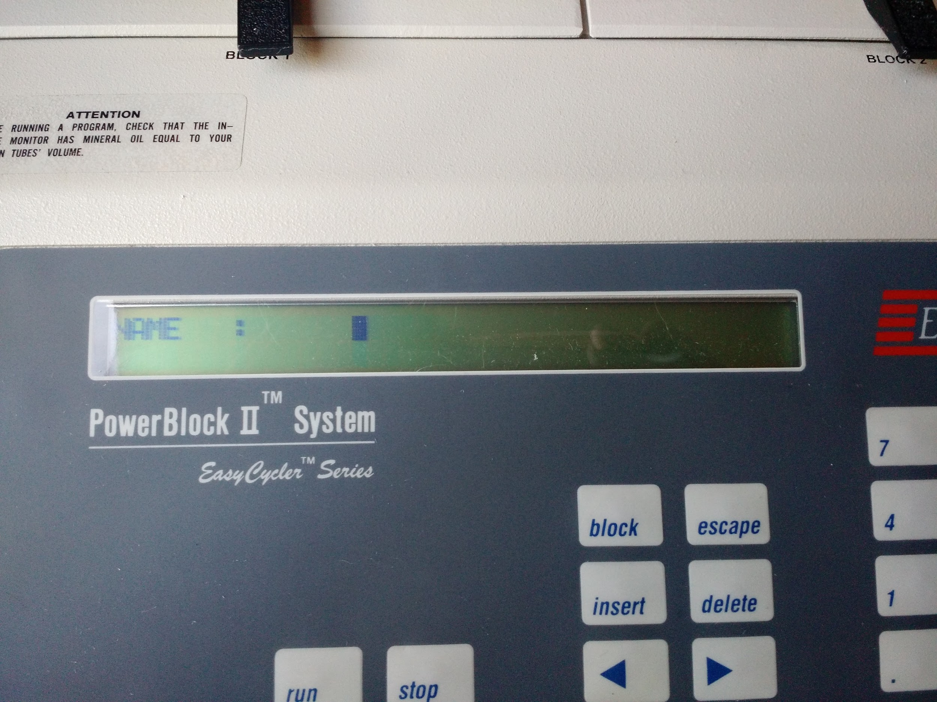

Press enter twice to goto the next screen

Choose 1 for temp

95 enter

Use arrows to navigate to minutes

1 for temp

95 enter for 30 seconds enter

55 for 30 seconds enter

68 for 30 a seconds enter

Select 2 for goto

Goto step 2 35 times

Select 1 for temp

68 for 6 minutes

5 for 1 hour

3 to end

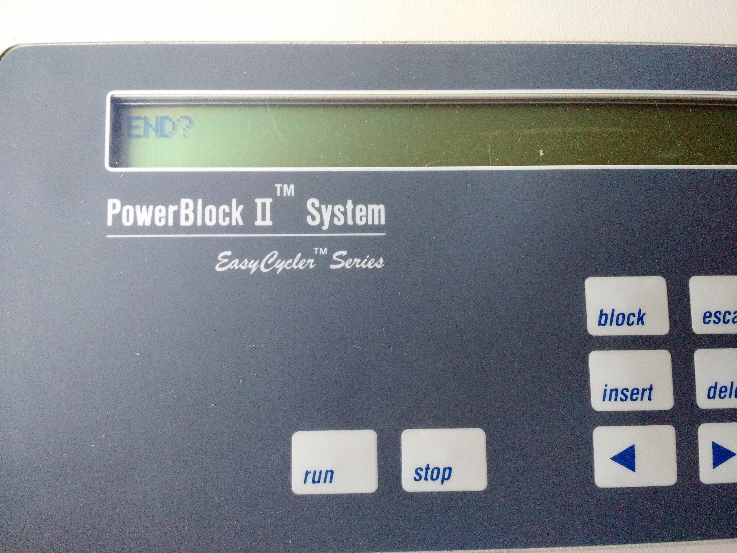

Enter to confirm

1 to run program

1 for tubes

2 for 50ul